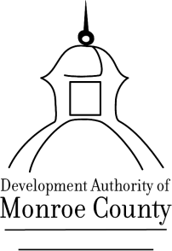
DEVELOPMENT AUTHORITY OF MONROE COUNTY
199 East Main Street

Special Called Board Meeting
April 18, 2022, 12 noon
199 E. Main Street
Forsyth, GA 31029
Minutes

The Development Authority of Monroe County (“the Authority”) special called board meeting was held at 199 East Main Street, Forsyth, GA on April 18, 2022 at 12:00 noon. Notice of the time, place, and purpose of said meeting was duly given to all Authority members and to the public, as provided in the Authority by-laws and by law.

The meeting was open to the public.

Development Authority Board members present were: Tom Baugh-Chairman, Larry Evans –Secretary/Treasurer, Greg Head – Assistant Secretary/Treasurer, Directors- Wendell Horne via phone, Michael Leverett, Phil Ham,and George Emami. Joyce White – Executive Director and Bob Harris-Attorney were also present.

Absent were Vice Chairman Jim Cole and Member Craig Craddock.

Meeting Called to Order

Chairman Tom Baugh called the meeting to order at 12:00 noon and declared there was a quorum.

Review and Approval of Agenda

Chairman Tom Baugh called for a motion to approve the agenda. Mr. Mike Leverett made a motion to approve the agenda. Mr. Greg Head seconded the motion. The motion passed unanimously.

Executive Session

Started at 12:01. Motion to begin executive session was made by Larry Evans and seconded by Phil Ham. The motion passed unanimously.

Ended at 12:42. Motion to exit executive session made by Mr. Mike Leverett and this motion was seconded by Mr. Phil Ham. The motion to exit passed unanimously.

No votes were taken. No motions or decisions made.

Adjournment

Chairman Tom Baugh called for a motion to adjourn at 12:43. Phil Ham made the motion to adjourn and Mike Leverett seconded the motion. The motion passed unanimously.

Respectfully Submitted: Joyce White

