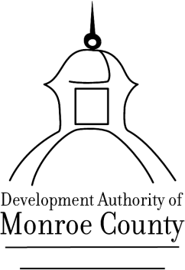

CANCELLATION NOTICE

Of Regular Board Meeting
TOM BAUGH July 11, 2022, 8:30 a.m.
Chairman 199 E, Main Street, Forsyth, GA 31029

JIM COLE
Vice Chairman

GREG HEAD
Assistant Secretary/Treasurer Please note that due to a potential lack of quorum

WENDELL HORNE on July 11, 2023, the regularly scheduled
Director
Board Meeting, of the Development Authority of
GREG TAPLEY
Director Monroe County will be cancelled. The next regularly

PHIL HAM scheduled Board Meeting will take place on August 8,
Director
2023, at 8:30 a.m.
CRAIG CRADDOCK
Director

MICHAEL LEVERETT
Director

GREG GOOLSBY
Director

JOYCE WHITE
Executive Director

BOB HARRIS
Attorney

“Monroe County Invites Industry”
199 E. Main Street  Forsyth, Georgia 31029

