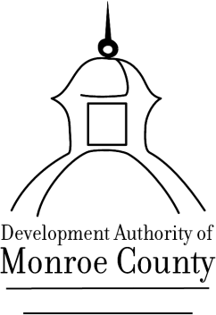

CANCELLATION NOTICE

Of Regular Board Meeting
TOM BAUGH December 12, 2023 8:30 a.m.
Chairman 199 E, Main Street, Forsyth, GA 31029

JIM COLE
Vice Chairman

GREG HEAD
Assistant Secretary/Treasurer Please note that due to a potential lack of quorum

WENDELL HORNE on December 12, 2023, the regularly scheduled
Director
Board Meeting, of the Development Authority of
GREG TAPLEY
Director Monroe County will be cancelled.

PHIL HAM
Director

CRAIG CRADDOCK
Director

MICHAEL LEVERETT
Director

GREG GOOLSBY
Director

JOYCE WHITE
Executive Director

BOB HARRIS
Attorney

“Monroe County Invites Industry”
199 E. Main Street  Forsyth, Georgia 31029

